Patient survey – The GUSTO study
Purpose of the Study:
We want to improve how well patients with muscle-invasive bladder cancer respond to treatment and how well they survive following treatment. To do this we are designing a study and we would like to know your thoughts.

Background:
How Cancer Develops: Cancer develops when the genes within a cell mutate and cause cancers to grow. These genes also control how cancers respond to treatment. Some bladder cancers have ‘genetic patterns’ that respond well to chemotherapy, whilst others do not. Other cancers may contain genetic patterns that ‘turn off’ the immune system, these cancers can be treated with a drug that turns the immune system back ‘on’. This kind of treatment is called immunotherapy.

The Current Treatment Situation: Currently, the treatment for invasive bladder cancer usually involves chemotherapy followed by surgery (bladder removal). Occasionally some patients may have chemotherapy after surgery instead. This is called the standard of care.

Why This Study Is Needed: Currently, some patients receive chemotherapy that is of little benefit to them. This may cause debilitating side effects and delays necessary bladder removal. Our proposed study would mean that patients with cancers that do not need chemotherapy, will get faster bladder removal and will benefit by not receiving unnecessary chemotherapy.

Currently, no patients receive immunotherapy before bladder removal. Our proposed study would mean that suitable cancers will receive both chemotherapy and immunotherapy. We hope that both of these changes will improve survival rates and quality of life.

The GUSTO study: We think that a personalised treatment pathway based on the patterns of genes mentioned above might improve the outcome for patients.

The treatment pathways we want to investigate are:
- Chemotherapy and immunotherapy before surgery for cancers with genetic patterns that suggest that the cancer will respond to both
- Immunotherapy alone before surgery for cancers with genetic patterns that suggests the cancer has turned the immune system “off”
- Neither treatment before surgery for cancers with genetic patterns which suggest the cancer would not respond to either chemotherapy or immune therapy. This would avoid delaying surgery with treatments that would not be expected to help.

Before testing our idea, we need to know if it can work in the NHS and if our treatment choices appear to work. To do this we need to treat and observe people on both treatment options; the current standard of care (chemotherapy followed by surgery) or one of the three new genetic pattern directed treatment pathways listed in the three bullet points above.
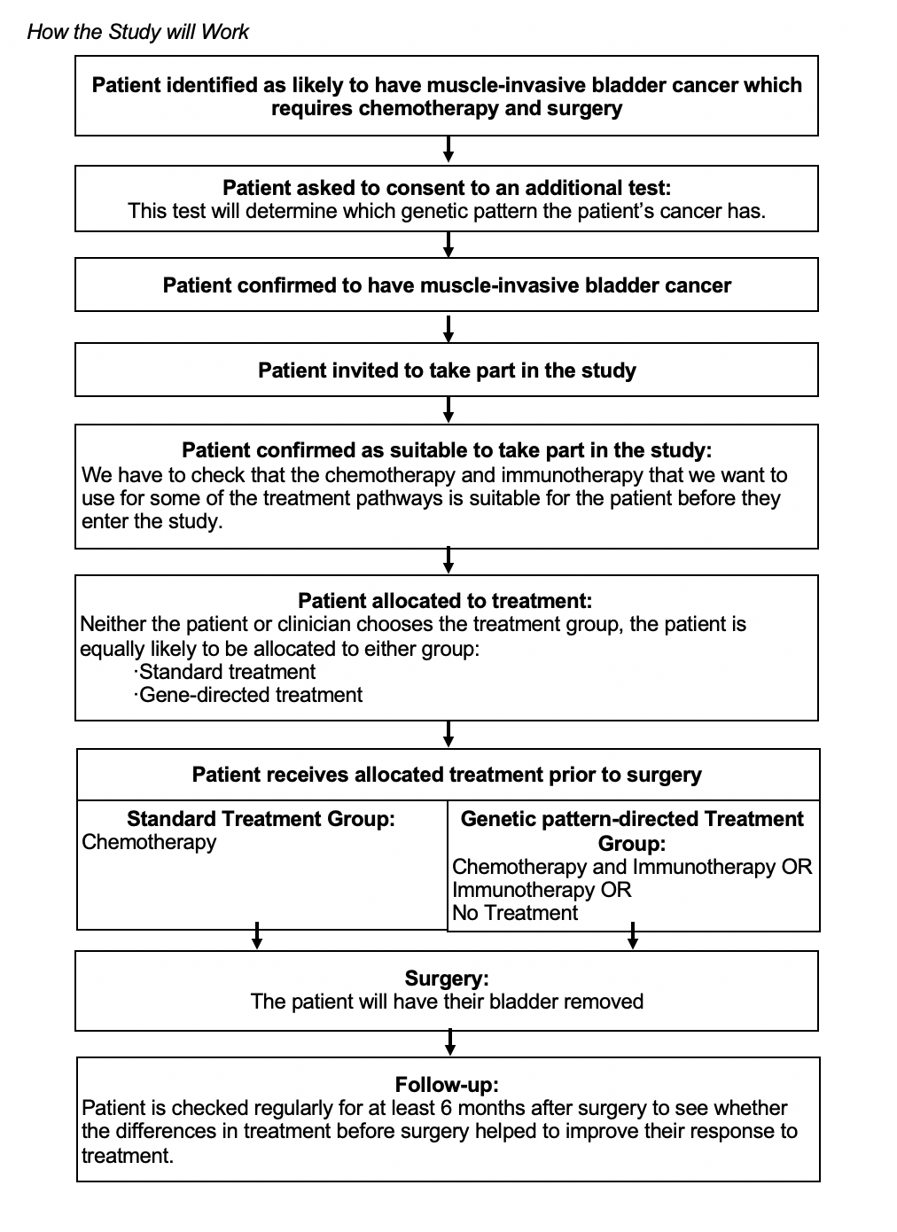

Potential risks of Entering the Study: Some patients will not receive chemotherapy before bladder removal. The risk is that the genes we measure do not accurately predict the actual response to the treatment the patient receives and so some patients may miss out on helpful treatments. To address this, these patients will have the opportunity to receive chemotherapy and immunotherapy later (after surgery).

Some Questions for You about the Proposed Study

Please answer the following questions so that we can find out what you think about our study to help us understand if it is possible:

- Do you agree that we need to improve survival and quality of life for patients with muscle-invasive bladder cancer?
YES / NO COMMENT:

- Have we explained our idea clearly enough so you can understand why we think it could work?
YES /NO COMMENT:

- Do you think our idea sounds interesting and do you think that patients would agree to take part?
YES /NO COMMENT:

- Do you think patients would agree to the additional genetic test before their confirmed diagnosis?
YES /NO COMMENT:

- If you were asked to enter the study, what information would you like to know to help guide your decision? COMMENT:

- Would you agree to enter a study in which we select the treatment for you based on the gene patterns in your cancer?
YES /NO COMMENT:

- If you entered the study would you like to know the genetic pattern of your cancer?
YES /NO COMMENT:

- Would you agree to receive standard treatment after entering the study if you were allocated to it?
YES /NO COMMENT:

- If you entered the study, would you agree to receive treatment on the basis of the genetic patterns in your cancer?
YES /NO COMMENT:

- If you entered the study, would you be happy to not receive chemotherapy or immunotherapy prior to surgery on the basis of the genetic patterns in your cancer?
YES /NO
COMMENT:

- If you entered the study, would you be happy to receive immunotherapy as well as chemotherapy if the genetic patterns in your cancer suggested it was of benefit?
YES /NO COMMENT:

- If you entered the study, would you be happy to receive immunotherapy instead of chemotherapy if the genetic patterns in your cancer suggested it was of benefit?
YES /NO COMMENT:

